**OUTPUT**

Case 1: if c = 'y'; a = 10, b = 2; choice = 1

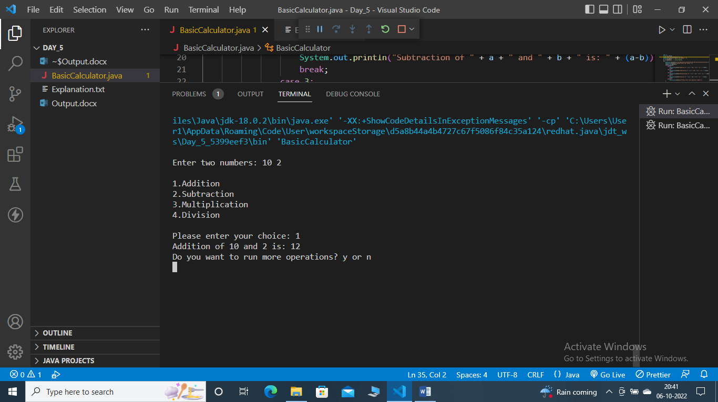

Case 2: if c = 'y'; a = 10, b = 2; choice = 2

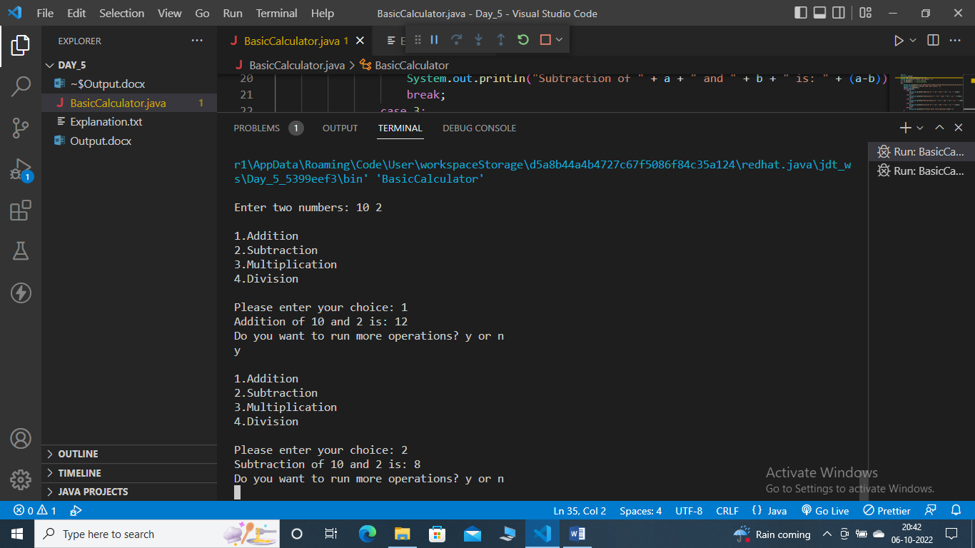

Case 3: if c = 'y'; a = 10, b = 2; choice = 3

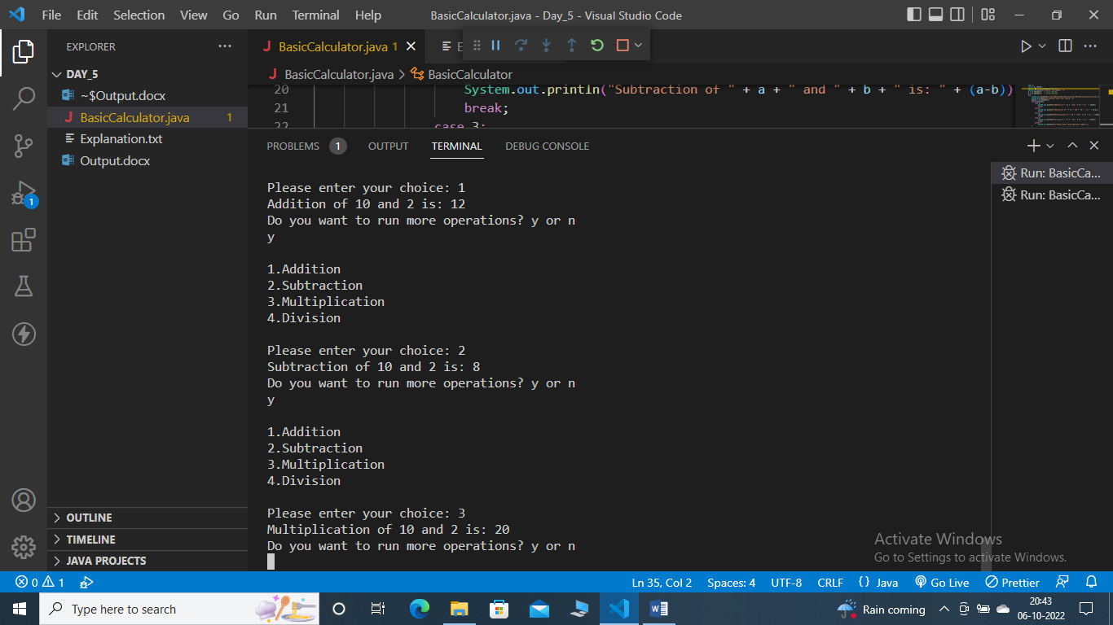

Case 4: if c = 'y'; a = 10, b = 2; choice = 4

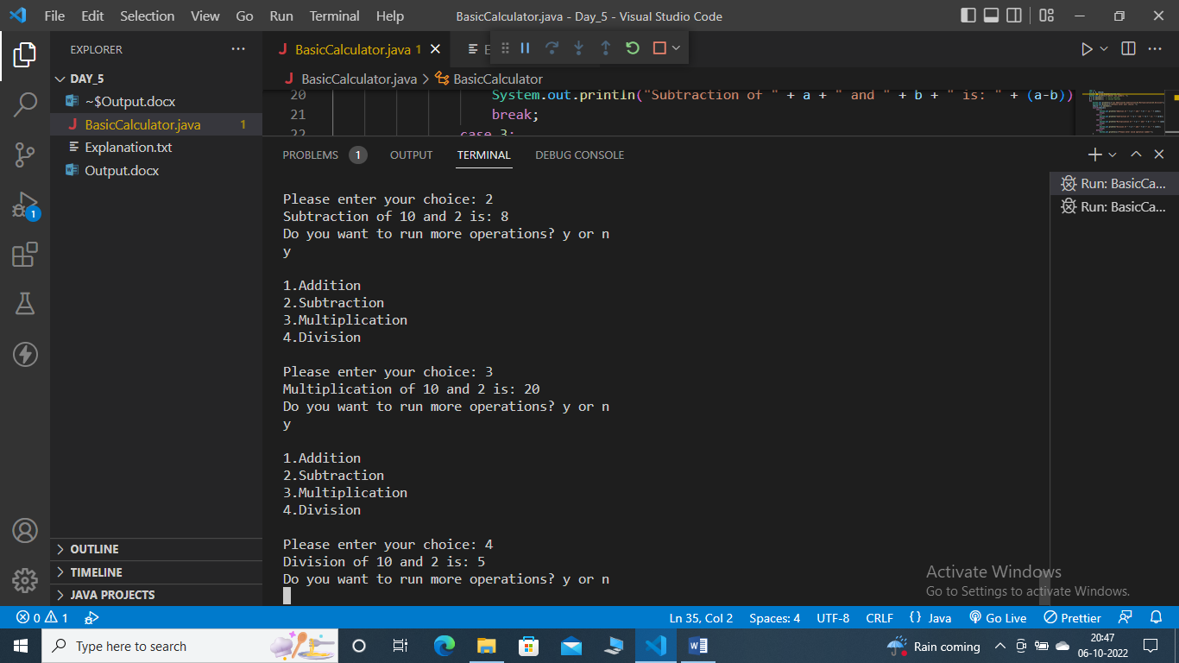

Case 5: if c = 'y'; a = 10, b = 2; choice = 5

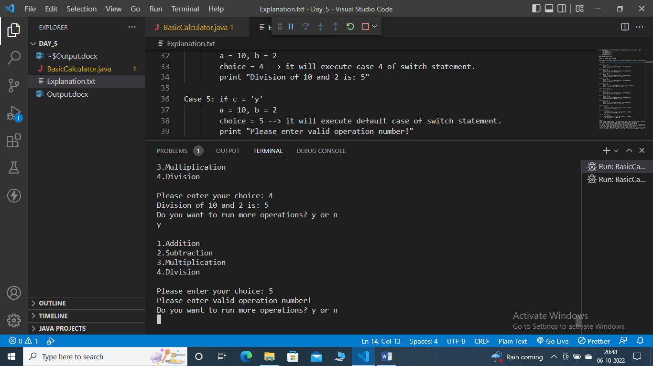

Case 6: if c = 'n'

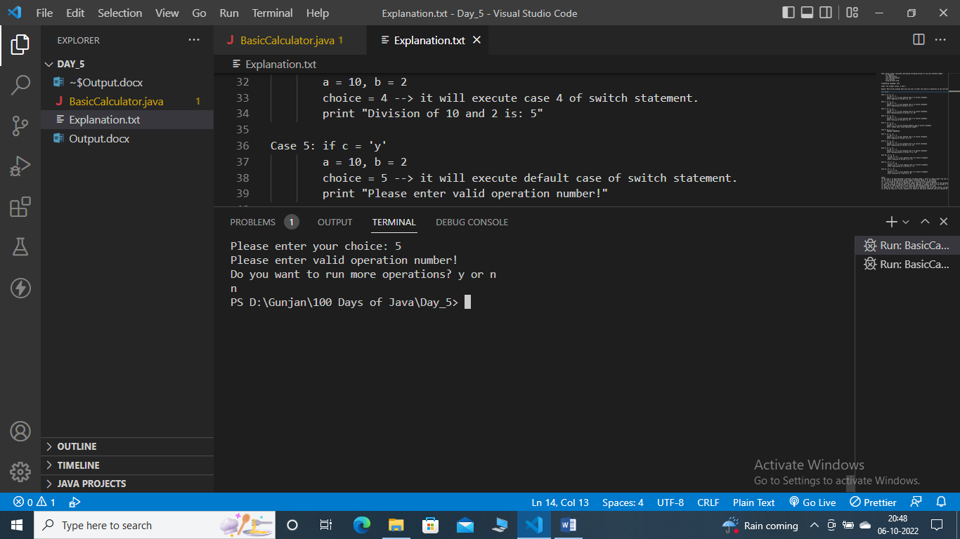

Case 7: if c = 'y'; a = 10, b = -2; choice = 1

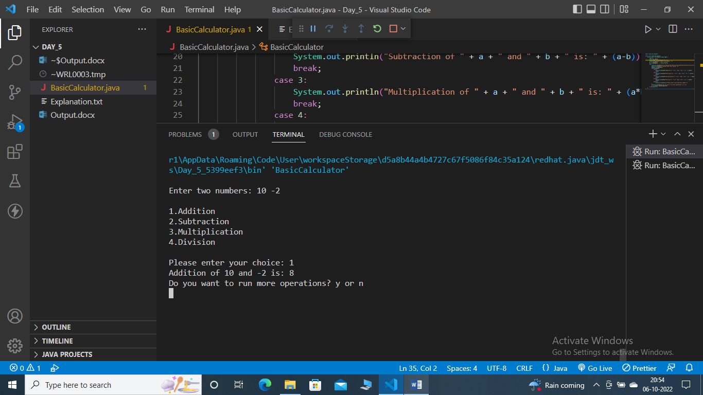

Case 8: if c = 'y'; a = 10, b = -2; choice = 2

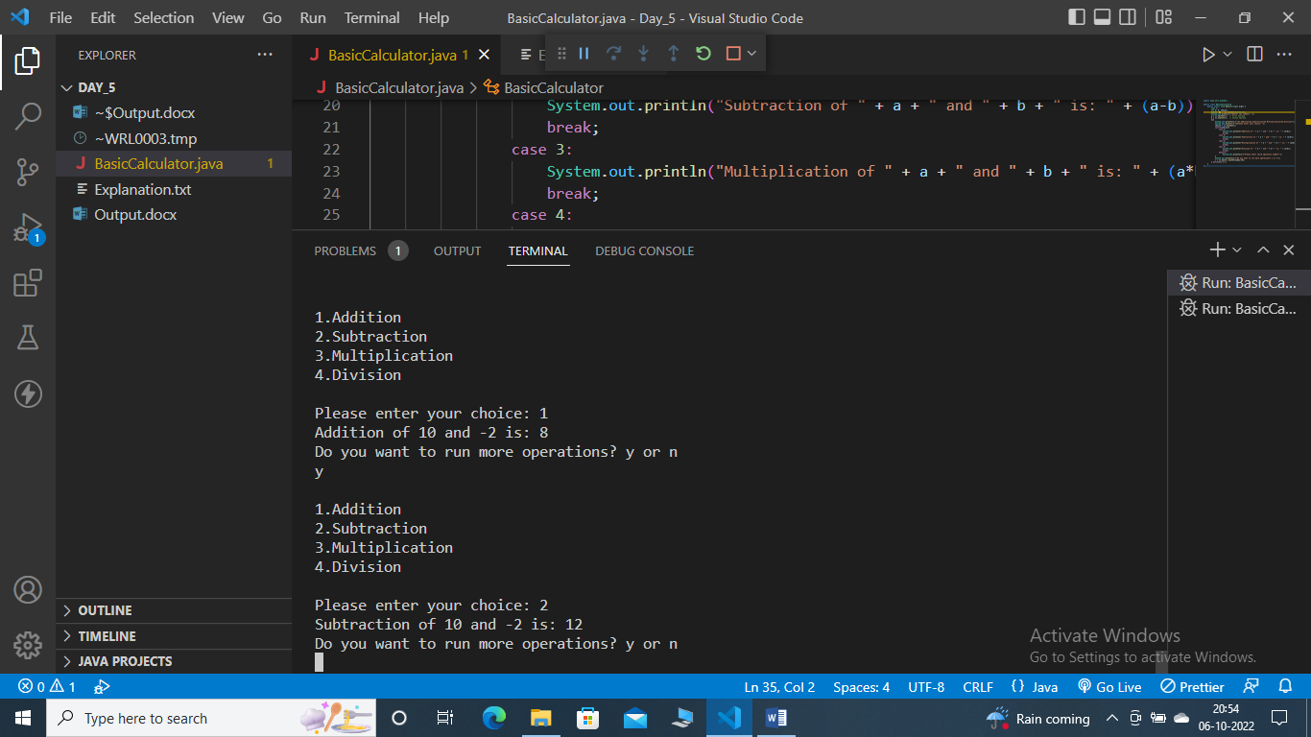

Case 9: if c = 'y'; a = 10, b = -2; choice = 3

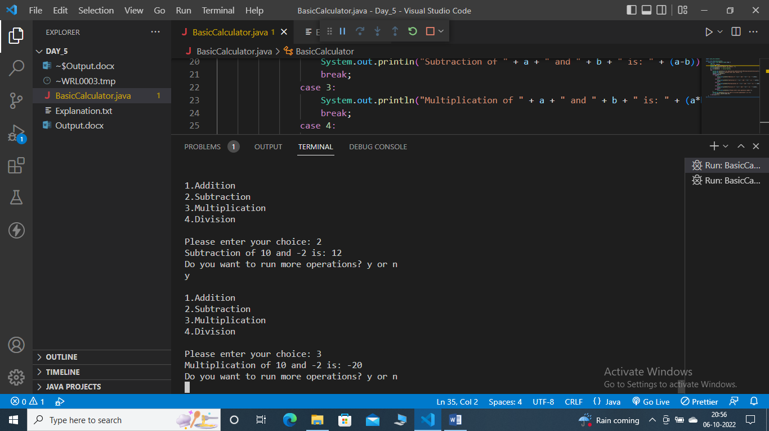

Case 10: if c = 'y'; a = 10, b = -2; choice = 4

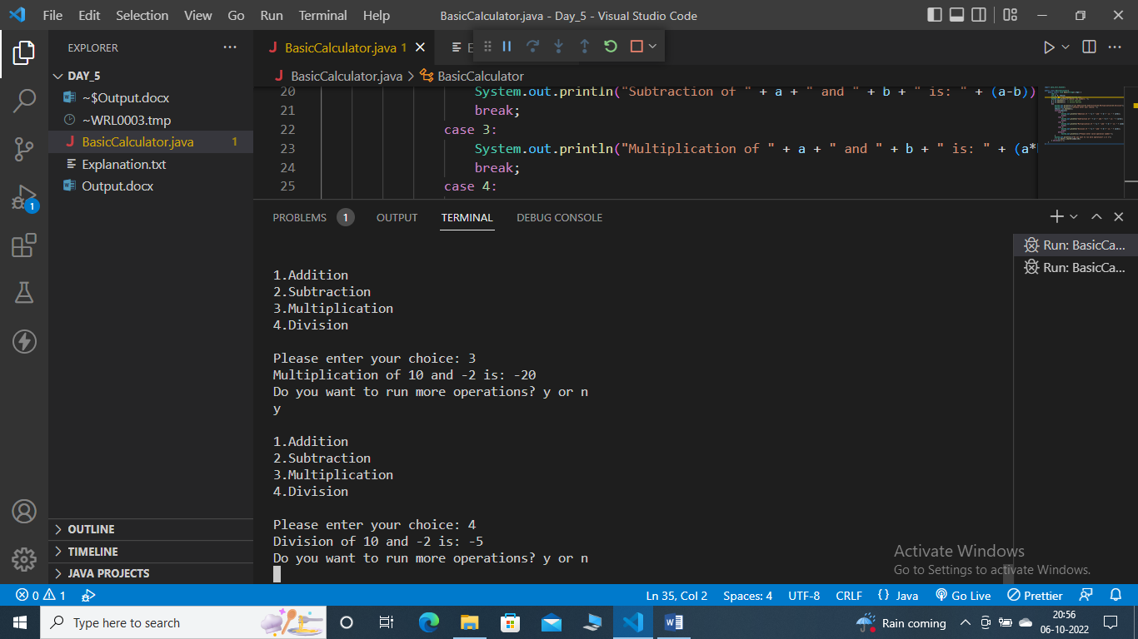

Case 11: if c = 'y'; a = 2, b = 10; choice = 2

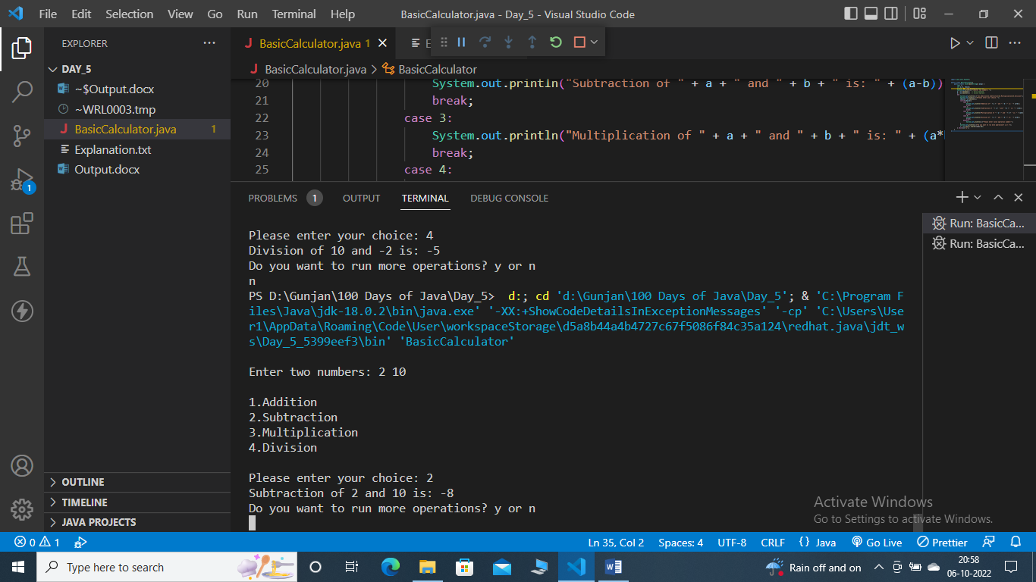

Case 12: if c = 'y'; a = 2, b = 10; choice = 4

